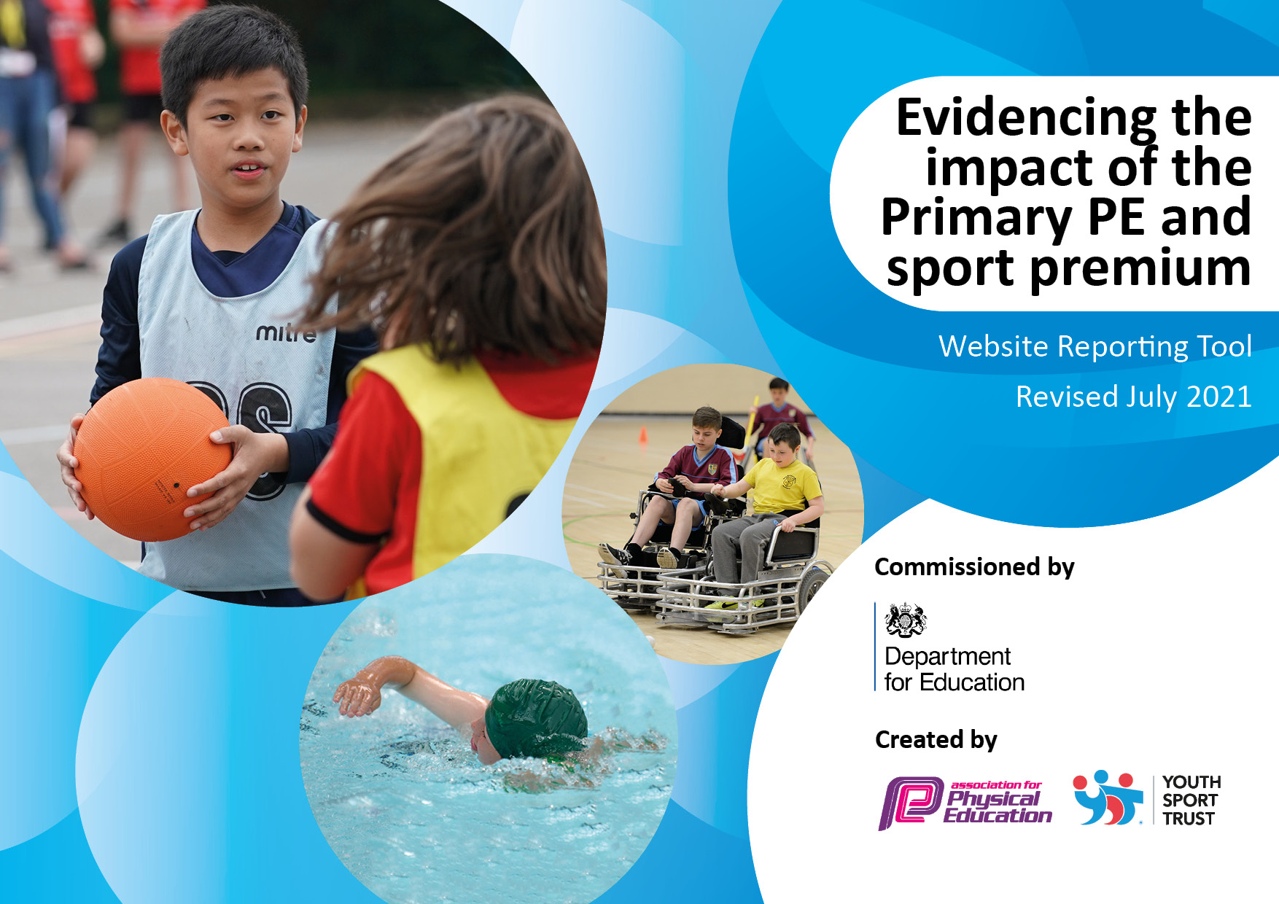

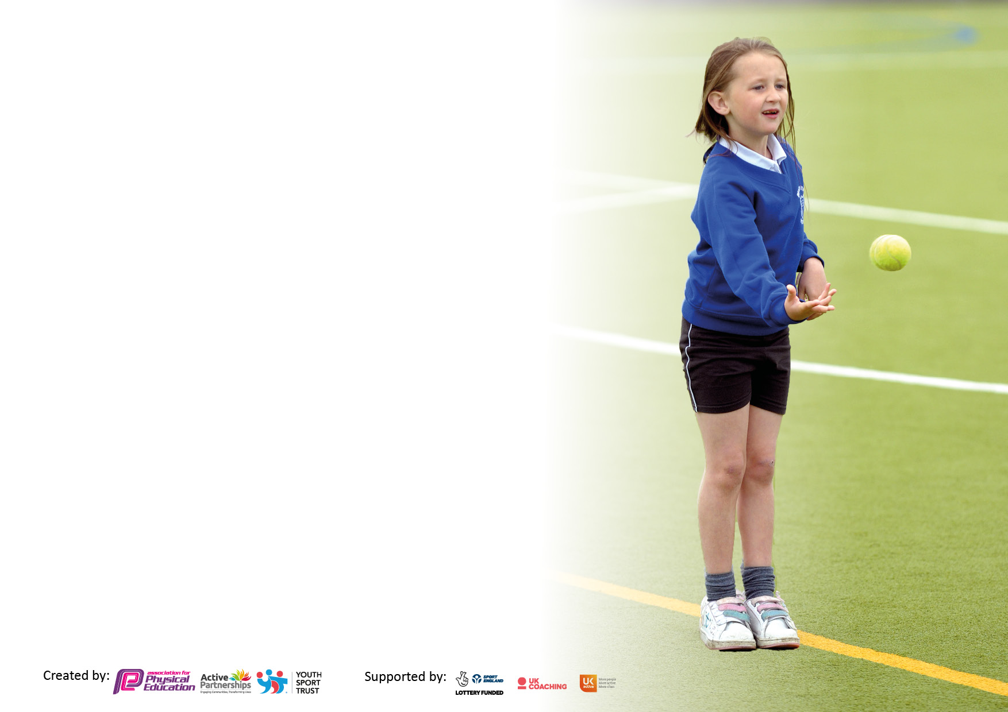

It is important that your grant is used effectively and based on school need. The [Education Inspection Framework](https://assets.publishing.service.gov.uk/government/uploads/system/uploads/attachment_data/file/843108/School_inspection_handbook_-_section_5.pdf) makes clear there will be a focus on **‘whether leaders and those responsible for governors all understand their respective roles and perform these in a way that enhances the effectiveness of the school’**.

Under the [Quality of Education](https://assets.publishing.service.gov.uk/government/uploads/system/uploads/attachment_data/file/843108/School_inspection_handbook_-_section_5.pdf) Ofsted inspectors consider:

**Intent** - Curriculum design, coverage and appropriateness

**Implementation** - Curriculum delivery, Teaching (pedagogy) and Assessment

**Impact** - Attainment and progress

To assist schools with common transferable language this template has been developed to utilise the same three headings which should make your plans easily transferable between working documents.

Schools must use the funding to make **additional and sustainable** improvements to the quality of Physical Education, School Sport and Physical Activity (PESSPA) they offer. This means that you should use the Primary PE and sport premium to:

* Develop or add to the PESSPA activities that your school already offer
* Build capacity and capability within the school to ensure that improvements made now will benefit pupils joining the school in future years
* The Primary PE and sport premium should not be used to fund capital spend projects; the school’s budget should fund these.

Pleasevisit[gov.uk](https://www.gov.uk/guidance/pe-and-sport-premium-for-primary-schools)fortherevisedDfEguidanceincludingthe5keyindicatorsacrosswhichschoolsshoulddemonstrate animprovement.Thisdocumentwillhelpyoutoreviewyourprovisionandtoreportyourspend.DfEencouragesschools to use this template as an effective way of meeting the reporting requirements of the Primary PE and sport premium.

We recommend you start by reflecting on the impact of current provision and reviewing the previous spend.

Schools are required to [publish details](https://www.gov.uk/guidance/what-maintained-schools-must-publish-online#pe-and-sport-premium-for-primary-schools) of how they spend this funding, including any under-spend from 2019/2020, as well as on the impact it has on pupils’ PE and sport participation and attainment. **All funding must be spent by 31st July 2022.**

We recommend regularly updating the table and publishing it on your website throughout the year. This evidences your ongoing self-evaluation of how you are using the funding to secure maximum, sustainable impact. Final copy must be posted on your website by the end of the academic year and no later than the 31st July 2021. To see an example of how to complete the table please click [HEaRE](http://www.afpe.org.uk/physical-education/wp-content/uploads/afPE-Example-Template-Indicator-2018-Final.pdf).



**Details with regard to funding**

Please complete the table below.

|  |  |
| --- | --- |
| Total amount carried over from 2019/20 | £8658.43 |
| Total amount allocated for 2020/21 | £18650 |
| How much (if any) do you intend to carry over from this total fund into 2021/22? | £15,019.40 |
| Total amount allocated for 2021/22 | £18650 |
| Total amount of funding for 2021/22. To be spent and reported on by 31st July 2022. | £33,669.40 |

**Swimming Data**

Please report on your Swimming Data below.

|  |  |
| --- | --- |
| **Meeting national curriculum requirements for swimming and water safety.**  N.B. Complete this section to your best ability. For example you might have practised safe self-rescue techniques on dry land which you can then transfer to the pool when school swimming restarts.  **Due to exceptional circumstances priority should be given to ensuring that pupils can perform safe self rescue even if they do not fully meet the first two requirements of the NC programme of study** | 22% |
| What percentage of your current Year 6 cohort swim competently, confidently and proficiently over a distance of at least 25 metres?  **N.B.** Even though your pupils may swim in another year please report on their attainment on leaving primary school at the end of the summer term 2021.  Please see note above | 54% |
| What percentage of your current Year 6 cohort use a range of strokes effectively [for example, front crawl, backstroke and breaststroke]?  Please see note above | 35% |
| **What percentage of your current Year 6 cohort perform safe self-rescue in different water-based situations?** | 43% |
| Schools can choose to use the Primary PE and sport premium to provide additional provision for swimming but this must be for activity **over and above** the national curriculum requirements. Have you used it in this way? | Yes/No |

**Action Plan and Budget Tracking**

Capture your intended annual spend against the 5 key indicators. Clarify the success criteria and evidence of impact that you intend to measure to evaluate for pupils today and for the future.

|  |  |  |  |  |  |
| --- | --- | --- | --- | --- | --- |
| **Academic Year:** 2021/22 | **Total fund allocated**:£33,669.40 | **Date Updated:** July 2022 | | |  |
| **Key indicator 1:** The engagement of all pupils in regular physical activity – Chief Medical Officers guidelines recommend that primary school pupils undertake at least 30 minutes of physical activity a day in school | | | | | Percentage of total allocation: |
| £10,951 =33% |
| **Intent** | **Implementation** | | | **Impact** |  |
| Your school focus should be clear what you want the pupils to know and be able to do and about  what they need to learn and to  consolidate through practice: | Make sure your actions to achieve are linked to your intentions: | Funding allocated: | | Evidence of impact: what do pupils now know and what can they now do? What has changed?: | Sustainability and suggested next steps: |
| <https://digital.nhs.uk/news/latest-news/significant-increase-in-obesity-rates-among-primary-aged-children-latest-statistics-show>  All pupils experience enriched  sporting activities which promote health, fitness and social  Interaction. Raise profile of pupils – Pupils to have more active roles by acting as sports leaders to ensure these activities continue.  A more active playground is developed.  Active Learning to be implemented across the school  Encourage children to be more active when travelling to and from school  The FAN Programme is an innovative series of group exercise sessions based around different fitness activities that are challenging, educational and fun. Each session also incorporates a nutrition theme so that pupils are getting an insight into both Fitness and Nutrition – both essential to the lifelong, healthy lifestyle journey.  Active Playtimes | 16 children in year 6 previously trained as play leaders. They will be paired with a year 5 child to enable them to show the year 5 children how to lead an active play session. We will look to make it more sustainable by including some Year 4 children also with year 5.  Timetable lunchtime activities for all classes. Use of Forest Schools Area.  Climbing wall for playground  Encourage staff to make their learning as active as possible in other subjects.  Virtual competitions to be organised by subject leader to promote staying active across the school.  Whole school (including families) taking part in GET SET ‘Bound for Beijing’.  Daily Mile – whole school  Join a travel to school reward scheme.  Health and Wellbeing week, including ‘MAD fitness’ delivered by Edsential.  More equipment to be ordered to be informed via pupil voice and Active play lead. | | £700  Booked extra sessions £700  £7301  £420  Booked extra sessions £420  £1410 | 36% of year 6 children are now play leaders.  Some Year 5 and 4 children have been peer trained as play leaders.  **Timetabled for 2022/23**  Forest Schools couldn’t start due to lack of training and therefore isn’t measurable  ______% children in KS2 are active at lunchtimes.  _____% children in F2 and KS1 are active at lunchtimes.  Company couldn’t install until Autumn Term 2022  Unable to complete  Every child in every class took part in ‘Bound for Beijing’. Children reported that they enjoyed seeing how many miles their class had ‘travelled’ and how this compared to other classes.  Started to be implemented – positive responses from class teachers  Unable to complete  Most children could explain to their teacher what they could do to keep fit and eat healthily. Most reported that the children in their class would like more than one fitness day per year.  **Timetabled for 2022/23**  Waiting order – impact to be measured in 2022/23 | * 16 Children in Year 5 to have the Play Maker award training in 2022/23. We will look to make it more sustainable by including some Year 4 children also with year 5.   Measure the impact in 2022/23  Impact to be measured next academic year  To be completed via Sports Council to promote staying active in school – They are to organise and collect data for this. This will be supported by Subject Leader.  A whole school approach to be being more active through ‘The World Cup’ including families.  Daily Mile to be implemented more in 2022/23 across whole school.  To be completed in 2022/23  ‘Mad Fitness Day’ to happen again next year. To enable it to be sustainable, PE lead will use this day as training to allow school to create their own fitness day run by PE Lead and school staff. We aim to have 3 fitness days per year (1 per term).  _______% children stated that they enjoy the lunch time activities. _____% children in F2 and KS1 are active at play times.  _____% children in KS2 are active at playtimes. |
| **Key indicator 2:** The profile of PESSPA being raised across the school as a tool for whole school improvement  **(Physical Education, School Sport and Physical Activity)** | | | | | Percentage of total allocation: |
| £10,040 = 30% |
| **Intent** | **Implementation** | | | **Impact** |  |
| Your school focus should be clear what you want the pupils to know and be able to do and about  what they need to learn and to  consolidate through practice: | Make sure your actions to achieve are linked to your intentions: | Funding allocated: | | Evidence of impact: what do pupils now know and what can they now do? What has changed?: | Sustainability and suggested next steps: |
| Promote and raise the profile of PE, sport and health and fitness across the school  “Physical literacy can be described as the motivation, confidence, physical competence, knowledge and understanding to value and take responsibility for engagement in physical activities for life.” CDP for Teachers.  Staff CPD and children sessions that promote yoga, mindfulness, growth mindset, resilience and managing emotions  A focus on stress reduction, management and coping techniques.  Staff Well being - Bespoke wellbeing sessions delivered after school to support staff in the self management of their physical well being and mental health.  Develop interpersonal skills, communication, problem solving and teamwork, build self-confidence and wellbeing. A key aim to meet the challenges of the transition from primary to secondary.  Focusing on social, emotional and mental health through being physically active.  FUNdamentals Programme  Target Year 1 children to improve:  1. Poor gross motor skills  2. Physical literacy of less active pupils  3. Early Years Physical Development (ELG) and school readiness | Create a ‘Sports Council’ within school. Each class from y4-6 will have their own class member of the Sports Council. This will help to engage all children in being active and Pupil Voice. The children will be more involved with how we can be more active in school.  Physical Literacy Course – IPLA.org.UK  Membership to be bought for 11 classes (Teachers). Teachers to complete the 6 part course as CPD for Physical Literacy. Staff to have full access to resources.  Edsential Rainbow Programme – Staff CPD and sessions with children - Yoga, mindfulness, growth mindset and managing emotions. Enable Staff to feel more equipped to use whole class sessions to support emotional wellbeing, including increasing resilience and tools to help relieve stress and anxiety. This method is more sustainable than using the outside yoga agency to run sessions.  Pre-SATS Programme A 6week programme designed for Year 6 pupils and staff focusing. Each session will support pupils in ways to manage their emotions in the lead up to and during tests.  Therapeutic approach includes mindfulness, yoga, breath awareness and relaxation.  The JASS award is progressive, with increasing commitment, learning and challenge. 14 Children in Year 5 will be given the opportunity to complete the Jazz Award with support for Edsential and PE lead.  Personal Best to continue. TA could attend session for CPD. This would then allow TA’s to deliver own school personal Best programme, therefore making it more sustainable.  Equipment for lessons  This programme combines the KS1 PE Age Related Expectations with Early Learning Goals physical development and aims to develop pupils with low gross motor skills. Each group takes part in carefully designed activities that focus on developing physical literacy. As a result of this, children should begin to develop resilience, confidence and a love of physical activity. The activities are not competitive; the key message is always about each young person developing physical literacy and improving their gross motor skills. At the start of each programme young people complete a baseline assessment relating to the Age Related Expectations for EYFS and Key Stage 1. | £20 (Sports Council Badges)  £20 x 10 =£200  £1700 (2hrs per week for 12 weeks)  Booked extra sessions £1700  6 x ½ days £850  Booked extra sessions £850  6 x 1hour £300  £250  £890  Booked extra sessions £890  £1,700  6 x ½ days  £720  Booked extra sessions £720 | | 12 children are part of the Sports Council. They have helped to raise the profile of PESSPA in their classes by creating, distributing and collating data of pupil voice for improving playtimes and lunchtimes.  Staff needed more time understand and become familiar with the new scheme of work. We decided to wait until next year before introduce this resource too.  All teachers reported that the children benefited from their sessions.  *There was* ***a significant jump in the number of children*** *reporting that they could 'always recognise when their feelings change'. (Self-awareness)*  *• There was also a* ***38% increase*** *in the number of children who reported they 'always know what to do when things are difficult'. (Resilience)*  *• At the end of the programme* ***0% of children*** *felt like they were 'never a nice person'. (Positive mental health).*  [Impact reports\12-Week Programme Impact Report (Summer Term).pdf](Impact%20reports/12-Week%20Programme%20Impact%20Report%20(Summer%20Term).pdf)  **Timetabled for 2022/23**  All teachers reported that the children benefited from their sessions.  *Following the programme, there was a* ***5% increase*** *in the number of children who reported they 'always know what to do when things are difficult'. (resilience).*  *There was a* ***significant increase*** *in the number of children who reported they can 'always' recognise when their feelings changed (self-awareness).*  *• Following the programme,* ***a further 13% of children*** *felt they were 'always a kind person'. (Positive mental health).*  [Impact reports\Y6 Rainbow prog - Impact Report (Summer Term - Year 6).pdf](Impact%20reports/Y6%20Rainbow%20prog%20-%20Impact%20Report%20(Summer%20Term%20-%20Year%206).pdf)  **Timetabled for 2022/23**  This was not completed as it was not of interest to most staff .  We were unable to book for 2021/22  Data collated and provided by Edsential.  [Impact reports\Personal Best Programme - Impact Report - Spring 2.pdf](Impact%20reports/Personal%20Best%20Programme%20-%20Impact%20Report%20-%20Spring%202.pdf)  **Timetabled for 2022/23**    Still waiting for delivery of some equipment  **Awaiting report from Edsential**  Positive feedback from staff.  _______% teachers now feel that the quality of their PE lessons have now improved due to extra PE equipment.  _______% of year 1 pupils have improved their gross motor skills.  _______% of year 1 children have became more active.  _______% Year 1 children have improved in their ELG.  **Timetabled for 2022/23** | To have more children part of the school council and take a more active role in active playtime and lunchtimes. Children to think of ways to promote healthy lifestyles across school (competitions ect).  To be bought in 2022/23  To repeat again in 2022/23 – Staff to use sessions as CPD  To repeat again in 2022/23 – Staff to use sessions as CPD  Book for 2022/23  To be competed again in 2023 – Staff to use as CPD  Impact to be measured 2023/23  Book again for 2022/23 |

|  |  |  |  |  |
| --- | --- | --- | --- | --- |
| **Key indicator 3:** Increased confidence, knowledge and skills of all staff in teaching PE and sport | | | | Percentage of total allocation: |
| £5,106.65 = 15% |
| **Intent** | **Implementation** | | **Impact** |  |
| Your school focus should be clear | Make sure your actions to | Funding | Evidence of impact: what do | Sustainability and suggested |
| what you want the pupils to know | achieve are linked to your | allocated: | pupils now know and what | next steps: |
| and be able to do and about | intentions: |  | can they now do? What has |  |
| what they need to learn and to |  |  | changed?: |  |
| consolidate through practice: |  |  |  |  |
| Improvements in the quality of Curriculum PE Teaching and Learning  Staff to continue to build on prior knowledge and skills   * PE lead to lead the PE curriculum with Increasing confidence. * Knowledge to be shared amongst colleagues.   Improved levels of attainment.  Safe practise in Physical Education, School Sport and Physical activity: Best practise for schools, help for Health and Safety and Risk assessments  Improvements in the quality of Curriculum PE Teaching and Learning and the design of the curriculum  Subject leader support.  Children to experience a broader PE curriculum, leading to an increased interest in PE and Sport, both within and outside of school. Staff CPD to enable this  Improvements in the quality of Curriculum PE Teaching and Learning and the design of the curriculum  Teachers to be trained in teaching swimming | To buy Edsentials assessment tool (including school passport) and new  PE scheme of work based on key skills to be taught. Record and present attainment in PE and competitions, clubs and events  To be used as CPD for staff for keeping children safe in PE lessons and to help them to identify any potential risks.  CPD to continue to support staff who may need support in specific areas of teaching and assessing PE. 4 Teachers to have 6 sessions each.  Subject leader support and advice from Edsential to help raise standards in school. The support also enables subject leader to stay most updated with current guidance and provides understand of what has changed and any ‘next steps’ that may need to follow.  Forest Schools – 4 x twilight sessions  Bespoke Forest School Sessions – 6 week programme (pm) (F2)  Bespoke Beach School Programme – 6 week programme pm (Year 6)  CPD staff meeting by PE lead to introduce schemes of work and assessment to all staff. Including a refresher on the progression of skills for each year group  AsA Teacher course (2 days) | £599  £300  Booked extra sessions £300  £51.65  £1780  Booked extra sessions £915 2x teachers  £675  Booked extra sessions £675  £850  £1,450 x 2 = 2,900  £0  £130 per person + supply = £410  X 2 =£820 | The assessment in the scheme of work was updated and therefore we decided to use this in line with the scheme.  Clear progression is evident in PE. All staff are using the scheme of working and following the curriculum map for their year group.  **Timetabled for 2022/23**  Used to inform teachers of safe practise of PE  Awaiting 3 x reports from Edsential.  [Impact reports\Edsential Curriculum Support Programme Impact Report - Spring 1.pdf](Impact%20reports/Edsential%20Curriculum%20Support%20Programme%20Impact%20Report%20-%20Spring%201.pdf)  **Timetabled for 2022/23**  Subject leader support has helped to increase subject leader’s confidence in leading PE and support. The support also enables subject leader to stay most updated with current guidance and provides understand of what has changed and any ‘next steps’ that may need to follow.  **Timetabled for 2022/23**  We were unable to book due to the high demand.  We were unable to book due to the high demand.  Curriculum design completed and amended. This outlines clear progression from F2-Y6.  1 x teacher completed due to other member of staff who was attending leaving | To review and compare assessment data in 2021/22 with 2022/23  To complete lesson ‘drop in’ to monitor the quality of teaching in PE. Complete Staff voice on their use of the scheme of work and ‘next steps’  Use to update PE policy in 2022/23  Use ‘Teacher voice’ to decide which teachers will receive CPD in PE to boost their confidence and competency in teaching PE.  Support to continue next year  Book for 2022/23  Book for 2022/23  ECT teacher to complete in 2022/23 |
| **Key indicator 4:** Broader experience of a range of sports and activities offered to all pupils | | | | Percentage of total allocation: |
| £6,875 = 20% |
| **Intent** | **Implementation** | | **Impact** |  |
| Your school focus should be clear | Make sure your actions to | Funding | Evidence of impact: what do | Sustainability and suggested |
| what you want the pupils to know | achieve are linked to your | allocated: | pupils now know and what | next steps: |
| and be able to do and about | intentions: |  | can they now do? What has |  |
| what they need to learn and to |  |  | changed?: |  |
| consolidate through practice: |  |  |  |  |
| Additional achievements:  Develop journeying, bouldering, orienteering and team building. Developing a wide range of curricular activity (twilight required)  To improve the forest area to encourage outdoor learning including team building, problem solving and orienteering. Develop interpersonal skills, communication, problem solving and teamwork, build self-confidence and wellbeing  We will provide the children with a broad range of skills taught. Alongside this, children will attend a range of events and experiences to ensure that they have the knowledge and passion to continue their journey of physical learning outside of our school and into later life.  Children to experience a broader PE curriculum, leading to an increased interest in PE and Sport, both within and outside of school.  Increase the amount of children who can swim in year 6  Circuits to help SEND children to regulate their emotions through physical activity. | Y4/5 Kayaking – taster session. Children given the opportunity to join club outside of school  Outdoor learning Cards  Equipment for the forest school area  Buy into Edsentials breakfast and after school club package to enable a range of new clubs available to the children.  Afterschool Tennis Club  Judo for Year 5 and 6 pupils  Create Dance Wirral to work with all year 2 children. The children will learn new dance skills and have the opportunities to perform at the Floral Pavilion. Children’s families can attend the Floral Pavilion to watch their performance.  Greater links to local clubs to be created - inviting local clubs into school.  Range of content taught well during PE lessons will lead to a greater uptake of after school clubs.  Quidditch Event Day – Whole day each class in KS2 to play the new sport. Each class in KS1 to have a taster session.  Additional activities for year 4 and 5 (adventure and team building)  Additional swimming weeks to target Y4 and Y5.  Sensory Circuits equipment | £450  £275  £4,000  1 x half term sessions £320  Tennis - Cost = £950 afterschool and curriculum sessions  To be paid by Parents.  £950  Booked extra sessions £950  EYFS Dance session booked £210  £495  £3,996.33  Swimming additional week Cost = £1075 x 2 =£2150  £850 | The cost had significantly increased and therefore it was no longer viable  Unable to timetable Twilight - Did not purchase due to not having forest school training.  Replaced with the climbing wall due to not having the forest school training  Needed to be moved to 2022/23 due to timetabling  All year groups from F2 to Y6 had 5 sessions. The attendance from these clubs increased from previous year (Bubble restrictions in previous year). SEND children targeted throughout the year with additional curriculum sessions.  **Timetabled for 2022/23**  **Timetabled for 2022/23**  Unable to book for 2021/22  See data below for Year 5 and Year 6. The current Year 6 data has been impacted by COVID (unable to swim until this year). Whereas the extra swimming for Year 5 has had a significant impact.  [Impact reports\Saints Peter and Paul Catholic Primary School_ Swimming Report (2).pdf](Impact%20reports/Saints%20Peter%20and%20Paul%20Catholic%20Primary%20School_%20Swimming%20Report%20(2).pdf)        Sensory Circuit has been completed daily. Teachers have commented how the children have been calmer and concentrate better due to this | Buy equipment once forest school training has been delivered.  Impact to be reviewed in 2022/23  To book again for next year.  Prioritise self-rescue next year  Buy additional equipment for 2022/23 |

|  |  |  |  |  |
| --- | --- | --- | --- | --- |
| **Key indicator 5:** Increased participation in competitive sport | | | | Percentage of total allocation: |
| £696.75 = 2% |
| **Intent** | **Implementation** | | **Impact** |  |
| Your school focus should be clear | Make sure your actions to | Funding | Evidence of impact: what do | Sustainability and suggested |
| what you want the pupils to know | achieve are linked to your | allocated: | pupils now know and what | next steps: |
| and be able to do and about | intentions: |  | can they now do? What has |  |
| what they need to learn and to |  |  | changed?: |  |
| consolidate through practice: |  |  |  |  |
| All children from EYFS to Year 6 to have been to a sporting event or competition throughout the year. - The focus of this is to broaden their life experiences and to aid their social and emotional development. | Ensure virtual competitions happening throughout school to increase fitness levels that may have depleted during school closures, such as speed bounce  arrange and engage with cluster competitions  Engage with School Games competitions where possible  Create links with local sports clubs  Promote the ‘Daily Mile’ within school effectively  Subject Lead to have time to complete subject leader tasks | £276.75 for competitions , sports day and medals  £420 Supply costs for PE lead to meet for subject leader support and monitoring |  |  |

|  |  |
| --- | --- |
| Signed off by | |
| Head Teacher: |  |
| Date: |  |
| Subject Leader: |  |
| Date: |  |
| Governor: |  |
| Date: |  |